NAME; AKINOLA MARY TOSIN

STUDENT ID; VEPH/20B/DA103

Student Performance Analysis Dashboard
Outlines
- Introduction
- Story of the Data
- Data Splitting and Preprocessing
- Pre Analysis
- In Analysis
- Post Analysis and Insights
- Data Visualization and Charts
- Recommendations and Observations
- Conclusion
- References and appendices

Introduction
The Student Performance Analysis Dashboard was developed to provide a detailed, interactive overview of student academic performance, considering academic, behavioral, socioeconomic, and environmental factors. The dashboard enables educators, administrators, and policymakers to identify performance trends, recognize at-risk students, and implement data-driven interventions to improve learning outcomes.
Objectives of the analysis:
- Analyze the impact of multiple factors—ranging from study hours and attendance to parental involvement and access to resources—on exam scores.
- Identify students at risk of underperformance or excelling above expectations.
- Support informed decision-making for interventions, curriculum planning, and resource allocation.

The dataset is downloaded from kaggle
Link; https://www.kaggle.com/datasets/lainguyn123/student-performance-factors
Story of the Data
The dataset includes student-level academic and behavioral data, capturing factors that influence learning outcomes. Each record represents a student, while columns capture dependent and independent variables.

Key Fields
- Hours Studied – Average weekly study hours per student.
- Attendance – Percentage of classes attended.
- Parental Involvement – Level of parental engagement in academic activities.
- Access to Resources – Availability of learning materials, devices, and study aids.
- Extracurricular Activities – Participation in sports, clubs, or arts.
- Sleep Hours – Average sleep duration per night.
- Previous Scores – Historical academic performance.
- Motivation Level – Self-reported motivation toward studies.
- Internet Access – Availability and reliability of internet for academic use.
- Tutoring Sessions – Participation in supplementary learning programs.
- Family Income – Socioeconomic status indicator.
- Teacher Quality – Measured via evaluations or student feedback.
- School Type – Public, private, or charter.
- Peer Influence – Peer support and academic environment.
- Physical Activity – Regular engagement in exercise or sports.
- Learning Disability – Presence of any diagnosed learning challenges.
- Parental Education Level – Highest education level attained by parents.
- Distance from Home – Commute distance to school.
- Gender – Student gender.
- Exam Score – Final exam performance (dependent variable).
Stakeholders:
- Teachers – Identify students needing support.
- School Administrators – Plan curriculum improvements and allocate resources.
- Parents – Understand their child’s academic strengths and weaknesses.
- Policy Makers – Develop strategies for educational interventions.
Success Metrics:
- Improved identification of underperforming students.
- Insight into socioeconomic and behavioral factors affecting performance.
- Data-driven decisions for personalized student support.
Data Splitting and Preprocessing
Data Cleaning
- Missing Values: Imputed using median for numeric variables (hours studied, exam score) and mode for categorical variables (school type, gender).
- Duplicate Records: Removed duplicates based on student ID.
- Data Types: Ensured numeric fields were consistent for calculations; categorical variables encoded for analysis.
Data Transformation
Normalization: Standardized exam scores on a 100-point scale.
Categorization:
- Performance categories: High (≥85), Medium (70–84), Low (<70).
- Family income levels: Low, Medium, High.
- Parental education: High school, Undergraduate, Postgraduate.
Derived Metrics:
- Average study hours per week.
- Attendance efficiency: Exam score ÷ attendance percentage.
- Engagement index combining parental involvement, motivation, and peer influence.
Data Splitting
Student-level dataset: For individual performance and correlation analysis.
Class/School-level dataset: Aggregated metrics for school comparison and trend analysis.
Pre Analysis
Exploratory data analysis (EDA) focused on relationships between independent variables and exam scores:
- Descriptive Statistics: Mean, median, and distribution of hours studied, attendance, sleep hours, and exam scores.
- Correlation Analysis: Evaluated relationships between exam scores and factors like motivation level, tutoring sessions, parental education, and access to resources.
- Group Comparisons: Examined differences in exam scores by gender, school type, and family income.
- Outlier Detection: Identified unusually low or high values in study hours, sleep hours, and exam scores.
Key Observations
- Students with high parental involvement and access to resources tend to perform better.
- Motivation level and participation in tutoring sessions positively correlate with exam scores.
- Students with learning disabilities show significant performance gaps unless additional support is provided.
- Physical activity and sleep hours show mild positive correlation with performance.
- Peer influence and school type contribute to variance in exam scores.
Post Analysis
Post-analysis revealed actionable insights from the dataset:
- High-Performing Students: Typically have balanced study habits, good sleep patterns, and strong support systems (parental involvement, peer influence).
- At-Risk Students: Low attendance, limited access to resources, and minimal parental involvement are strong predictors of low exam scores.
- Socioeconomic Impact: Family income and parental education are significant indicators of student performance.
- Behavioral Patterns: Students engaged in extracurricular activities and physical activity maintain better cognitive and emotional balance, improving performance.
Data Visualization and Charts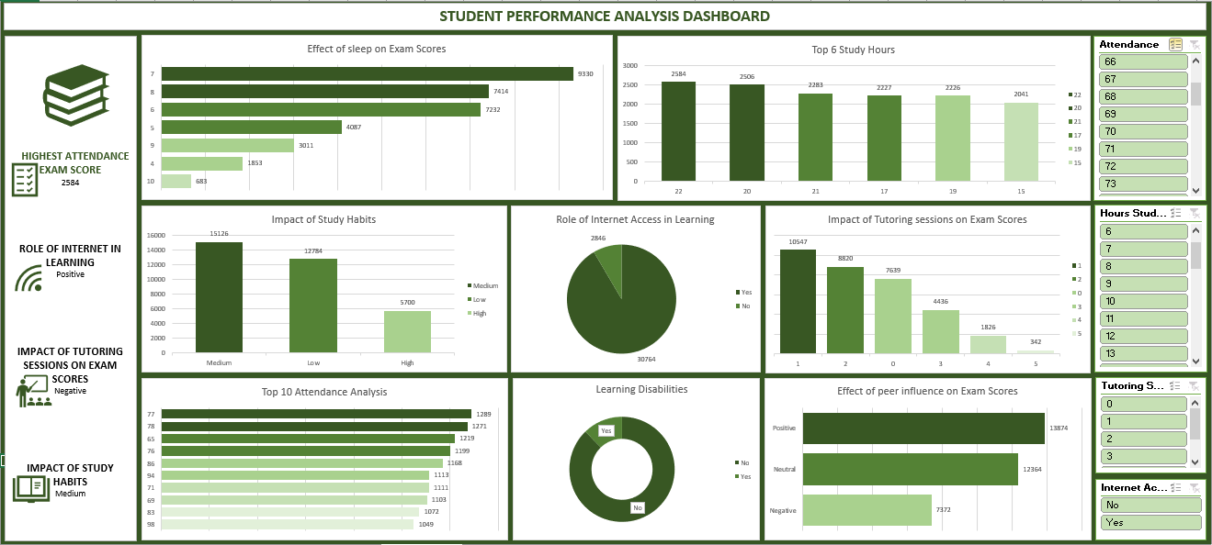
Effect of Sleep on Exam Scores
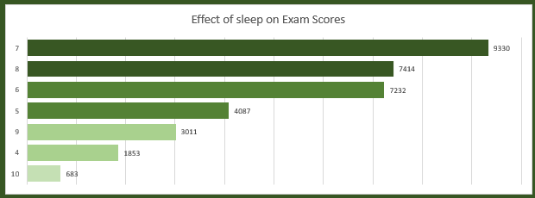
The chart illustrates a strong relationship between sleep duration and exam performance, showing that students who maintain adequate sleep hours tend to achieve significantly higher scores. Students averaging around 7–8 hours of sleep recorded the highest performance levels, suggesting optimal cognitive functioning within this range. In contrast, both insufficient sleep (below 5 hours) and excessive sleep show a noticeable decline in exam scores. This pattern highlights the importance of balanced sleep habits, as sleep deprivation negatively impacts concentration, memory retention, and overall academic efficiency.

Top 6 Study Hours

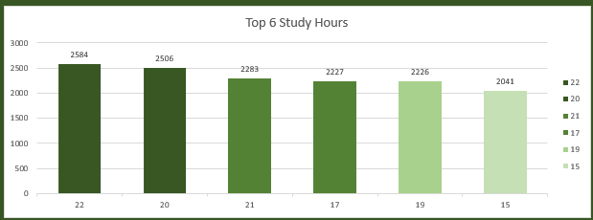
This visualization highlights the distribution of top-performing students based on study hours, revealing a positive correlation between time invested in studying and academic success. Students who studied between 20–22 hours achieved the highest exam scores, indicating that consistent and focused study routines contribute significantly to performance. However, the marginal differences among the top categories suggest that beyond a certain threshold, increased study hours yield diminishing returns, emphasizing the importance of study quality over quantity.
Impact of Study Habits
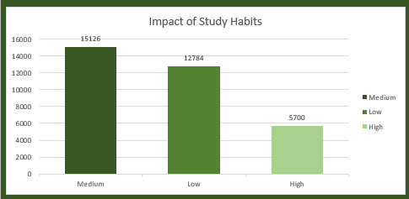
The chart demonstrates how different levels of study habits (Low, Medium, High) influence exam performance. Interestingly, students categorized under medium study habits achieved the highest scores, outperforming those in both low and high categories. This suggests that a balanced and structured study approach is more effective than either minimal effort or potentially overwhelming study intensity. High study habits may indicate burnout or inefficient study techniques, while low habits naturally correlate with weaker performance.
Role of Internet Access in Learning
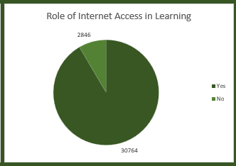
This pie chart shows that a significant majority of students with internet access achieved higher cumulative exam scores compared to those without access. This underscores the critical role of digital resources in modern education, including access to online learning platforms, research materials, and virtual tutoring. Students without reliable internet access are at a clear disadvantage, highlighting a digital divide that impacts academic outcomes.
Impact of Tutoring sessions on Exam Scores
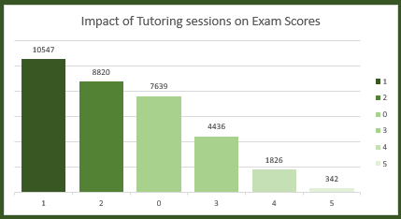
The chart reveals a clear trend where students who attend tutoring sessions perform better than those who do not. Students with at least 1–2 tutoring sessions show significantly higher scores, while those with no tutoring tend to perform lower. However, excessive tutoring sessions do not necessarily correspond to higher scores, suggesting that targeted and effective tutoring is more beneficial than frequent sessions without structure.
Top 10 Attendance Analysis
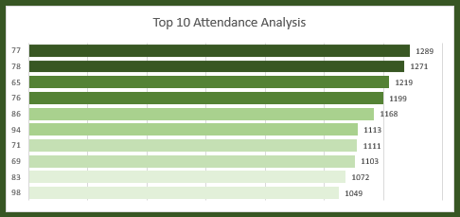
This visualization emphasizes the importance of consistent attendance in academic success. Students with attendance rates in the mid-to-high 70% range dominate the top performance category. The trend indicates that regular class participation enhances understanding, engagement, and retention of course material. Even small differences in attendance percentages can lead to noticeable variations in exam outcomes, reinforcing attendance as a key performance driver.

Learning Disablities
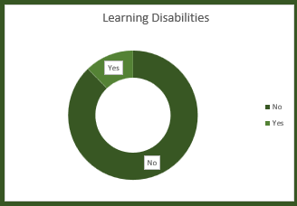
The donut chart highlights the performance gap between students with and without learning disabilities. Students without learning disabilities significantly outperform those with identified challenges, indicating the need for specialized academic support systems. This disparity suggests that without proper intervention, students with learning disabilities may struggle to reach their full academic potential.
Effect of Peer Influence on Exam Scores
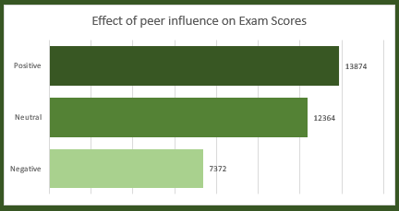
This chart demonstrates that peer influence plays a substantial role in academic performance. Students with positive peer influence achieved the highest exam scores, while those exposed to negative peer environments performed significantly lower. Neutral peer influence falls in between, indicating moderate impact. This underscores the importance of a supportive academic environment where peers encourage productivity, collaboration, and motivation.
Observations
- Academic performance strongly correlates with hours studied, parental involvement, and access to resources.
- Motivation and tutoring sessions amplify student performance, particularly for medium-performing students.
- Learning disabilities require targeted interventions to reduce performance gaps.
- Socioeconomic factors, including family income and parental education, influence exam outcomes.
- Lifestyle factors such as sleep and physical activity contribute positively but moderately.
- School type and peer influence can either enhance or impede student performance.
Recommendations
Intervention Programs:
- Provide targeted tutoring and mentoring for students with low exam scores or learning disabilities.
Parental Engagement:
- Encourage parents to actively participate in academic activities; workshops or guidance sessions can be implemented.
Resource Allocation:
- Ensure equitable access to learning resources and internet for all students.
Lifestyle Guidance:
- Promote balanced sleep and physical activity routines to support cognitive performance.
Monitoring Tools:
- Use the dashboard to flag at-risk students early and track the effectiveness of interventions.
School Policy Improvements:
- Adopt best practices from high-performing schools and peer groups for wider implementation
Conclusion
The Student Performance Analysis Dashboard enables stakeholders to understand complex relationships between academic, behavioral, and socioeconomic factors and student exam scores. By integrating multiple variables, the dashboard facilitates data-driven interventions, personalized support, and continuous monitoring of student outcomes.

